**Prerequisites:**

**Run command in mysql:-**

**mysql->** create database Personal;

**mysql->** use Personal;

**mysql->** create table Personal(Sno int(4),Name varchar(20),Telephone varchar(10),Gender char(1));

**In the file module-info.java**

type requires java.sql;

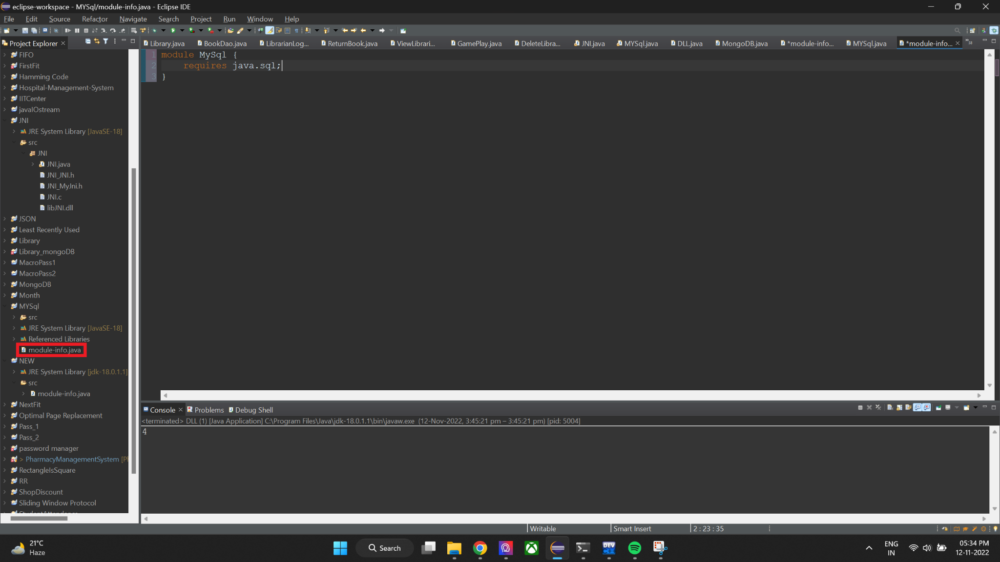

**…………………….....................................C O D E...............................................................**

package MYSql;

import java.sql.*;

import java.util.Scanner;

public class MYSql {

public static void main(String[] args) throws Exception {

int n,sno;

String name,telephone,gender;

Scanner in=new Scanner(System.in);

Class.forName("com.mysql.jdbc.Driver");

Connection con=DriverManager.getConnection("jdbc:mysql://localhost:3306/Personal","root","root");

Statement stmt=con.createStatement();

PreparedStatement pstm=con.prepareStatement("insert into Personal values(?,?,?,?)");

PreparedStatement pstm1=con.prepareStatement("delete from Personal where sno=?");

System.out.print("Enter the no of record you want to insert:");

n=in.nextInt();

for(int i=0;i<n;i++) {

System.out.print("\nData"+(i+1)+"\nEnter Sno:");

sno=in.nextInt();

pstm.setInt(1,sno);

System.out.print("Enter Name:");

name=in.next();

pstm.setString(2,name);

System.out.print("Enter Telephone:");

telephone=in.next();

pstm.setString(3,telephone);

System.out.print("Enter Gender:");

gender=in.next();

pstm.setString(4,gender);

pstm.executeUpdate();

}

ResultSet rs=stmt.executeQuery("Select * from Personal;");

System.out.println("\nAfter Insertion");

System.out.println("Sno\tName\tTelephone\tGender");

while(rs.next()){ System.out.println(rs.getInt(1)+"\t"+rs.getString(2)+"\t"+rs.getString(3)+"\t"+rs.getString(4));

}

System.out.print("Enter the no of record you want to delete:");

n=in.nextInt();

for(int i=0;i<n;i++) {

System.out.print("\nData"+(i+1)+"\nEnter Sno:");

sno=in.nextInt();

pstm1.setInt(1,sno);

pstm1.executeUpdate();

}

ResultSet rs1=stmt.executeQuery("Select * from Personal;");

System.out.println("\nAfter Deletion");

System.out.println("Sno\tName\tTelephone\tGender");

while(rs1.next()){ System.out.println(rs1.getInt(1)+"\t"+rs1.getString(2)+"\t"+rs1.getString(3)+"\t"+rs1.getString(4));

}

con.close();

}

}

**………………………………………………………………………………………………………………..**

**Step 1: Click on file properties**

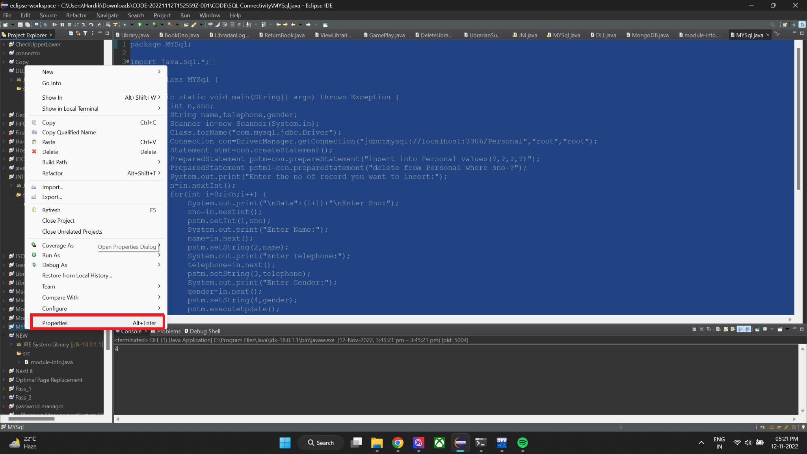

**Step 2: Click on java build path**

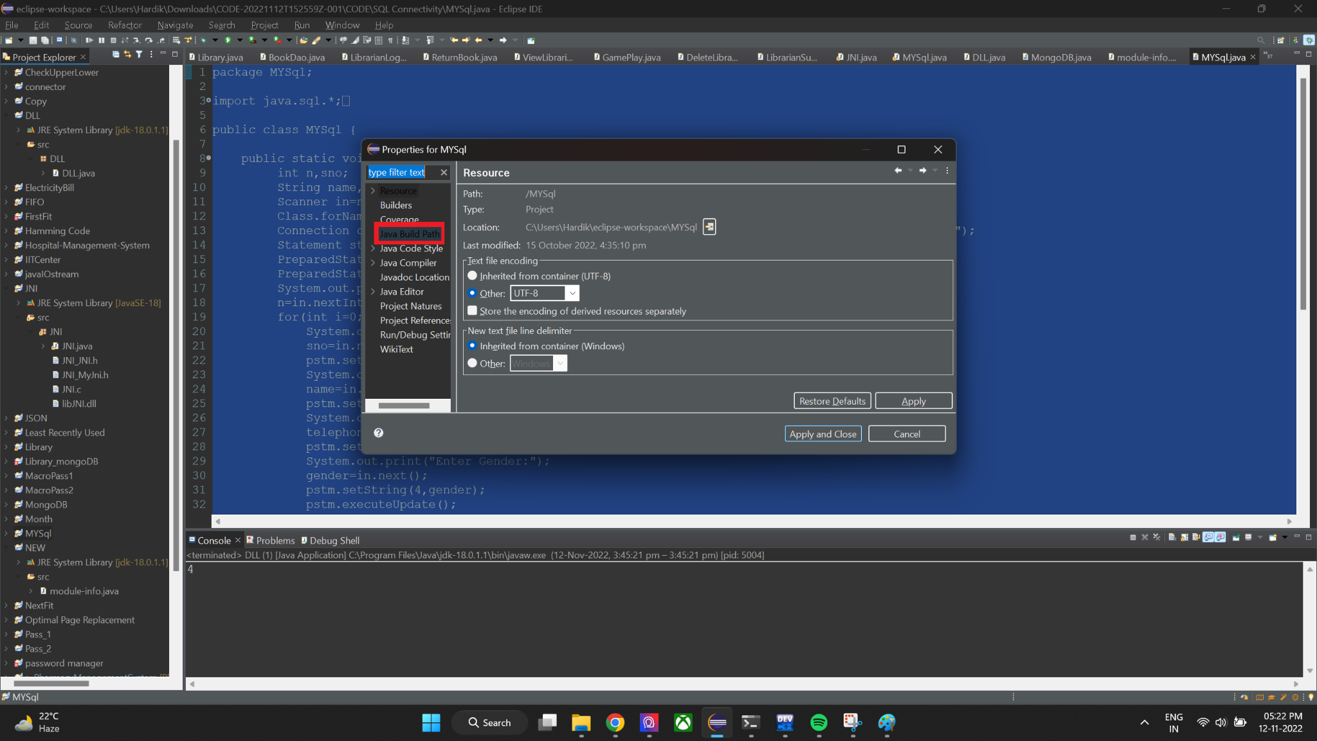

**Step 3: Class path add external jar file**

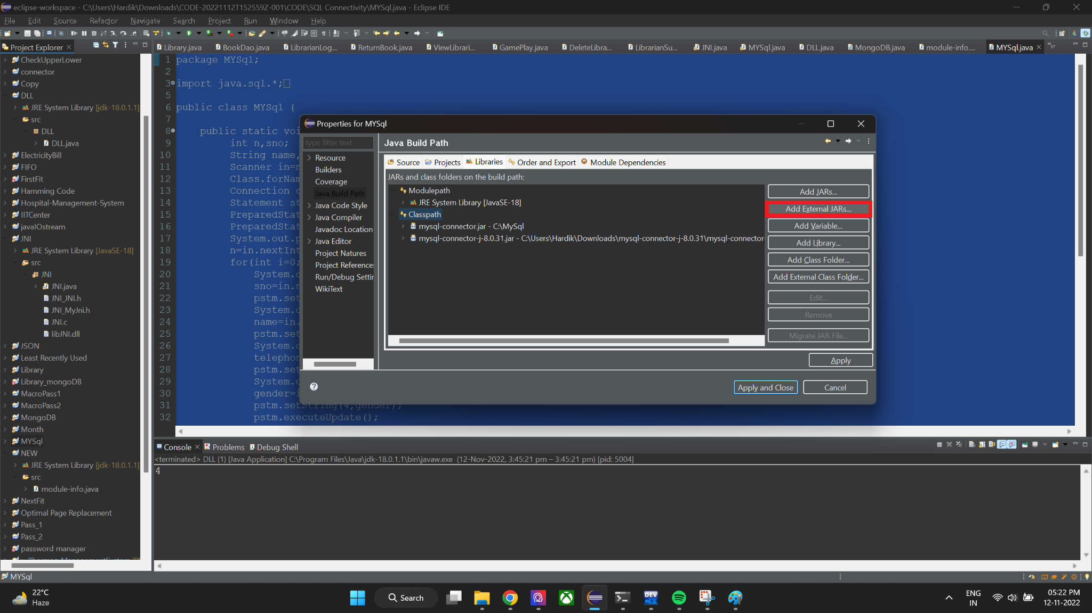

**Step 4: Locate jar file and select it to add it to the classpath** 